Project Planning Phase

Project Planning (Product Backlog, Sprint Planning, Stories, Story Points)
Date | 15-07-2026
Team ID | SWTID-2026-1581
Project Name | Credit Card Approval Prediction System
Maximum Marks | 5 Marks

Product Backlog, Sprint Schedule, and Estimation
Product backlog and sprint schedule for the Credit Card Approval Prediction System, broken into 4 sprints of 20 story points each (80 points total).
Sprint | Functional Requirement (Epic) | User Story Number | User Story / Task | Story Points | Priority | Team Members
Sprint-1 | Application Form (Data Input) | USN-1 | As an applicant, I can enter my personal details (age, education, marital status) in the form. | 3 | High | 2
Sprint-1 |  | USN-2 | As an applicant, I can enter my financial & employment details (income, employment type, years employed). | 3 | High | 2
Sprint-1 |  | USN-3 | As an applicant, I can enter my family & housing details (family size, car/property ownership). | 2 | High | 1
Sprint-1 |  | USN-4 | As an applicant, I want the form to validate my inputs before submission. | 3 | High | 1
Sprint-1 | Data Preprocessing | USN-5 | As the system, incoming form data is cleaned and encoded before prediction. | 3 | High | 2
Sprint-1 |  | USN-6 | As the system, engineered features (years employed, age) are derived from raw inputs. | 3 | Medium | 1
Sprint-1 |  | USN-7 | As the system, missing or invalid values are handled gracefully. | 3 | Medium | 1
Sprint-2 | Model Building | USN-8 | As a data scientist, I can train Logistic Regression, Decision Tree, Random Forest and XGBoost models on historical data. | 5 | High | 2
Sprint-2 |  | USN-9 | As a data scientist, I can compare models by F1-score and select the best-performing one. | 3 | High | 2
Sprint-2 |  | USN-10 | As a data scientist, I can tune the selected model's hyperparameters. | 3 | Medium | 1
Sprint-2 | Prediction Engine | USN-11 | As an applicant, I can submit my completed form and receive an instant Approved / Rejected decision. | 5 | High | 2
Sprint-2 |  | USN-12 | As an applicant, I want to see a short explanation of the key factors behind my result. | 4 | Medium | 1
Sprint-3 | Web Application | USN-13 | As an applicant, I can navigate a simple landing page describing the tool. | 2 | Medium | 1
Sprint-3 |  | USN-14 | As an applicant, I can view a clear Approved / Rejected result page. | 3 | High | 2
Sprint-3 |  | USN-15 | As an analyst, I can view applicant data alongside the prediction for borderline cases. | 5 | Medium | 2
Sprint-3 | Deployment | USN-16 | As an admin, I can deploy the trained model & Flask app to Render using a Procfile. | 5 | High | 2
Sprint-3 |  | USN-17 | As an admin, I can ensure the app is reachable via a live URL for demos. | 2 | High | 1
Sprint-3 |  | USN-18 | As a QA, I can test the end-to-end flow from form submission to result. | 3 | High | 1
Sprint-4 | Model Management | USN-19 | As an admin, I can retrain the model on updated historical data. | 5 | Low | 2
Sprint-4 |  | USN-20 | As an admin, I can persist and redeploy an updated model without downtime. | 5 | Low | 1
Sprint-4 | Monitoring & Documentation | USN-21 | As a team, I can document the architecture, DFD, and user stories for submission. | 3 | Medium | 2
Sprint-4 |  | USN-22 | As a team, I can prepare EDA visualizations (bar chart, pie chart, heatmap) for the report. | 4 | Medium | 1
Sprint-4 |  | USN-23 | As a team, I can write the final project report and demo video. | 3 | High | 2

Project Tracker, Velocity & Burndown Chart
Sprint | Total Story Points | Duration | Sprint Start Date | Sprint End Date (Planned) | Story Points Completed (as on Planned End Date) | Sprint Release Date (Actual)
Sprint-1 | 20 | 6 Days | 01 Jun 2026 | 06 Jun 2026 | 20 | 06 Jun 2026
Sprint-2 | 20 | 6 Days | 08 Jun 2026 | 13 Jun 2026 | 20 | 13 Jun 2026
Sprint-3 | 20 | 6 Days | 15 Jun 2026 | 20 Jun 2026 | 20 | 20 Jun 2026
Sprint-4 | 20 | 6 Days | 22 Jun 2026 | 27 Jun 2026 | 20 | 27 Jun 2026

Velocity
Velocity is the average amount of work (in story points) a team completes per sprint. Across all 4 sprints, the team completed 20 story points per sprint, so:
Velocity = Total Story Points Completed / Number of Sprints = (20+20+20+20) / 4 = 80 / 4 = 20 (Story Points per Sprint).
For a 6-day sprint duration, the team's average velocity (AV) per iteration unit (story points per day) is:
AV = Velocity / Sprint Duration = 20 / 6 ≈ 3.33 (Story Points per Day).

Burndown Chart
A burndown chart is a graphical representation of work remaining versus time. It is commonly used in Scrum to track whether a sprint is on pace to finish its committed story points. The chart below shows Sprint-1 of the Credit Card Approval Prediction System, comparing the ideal burn-down line against the team's actual progress.
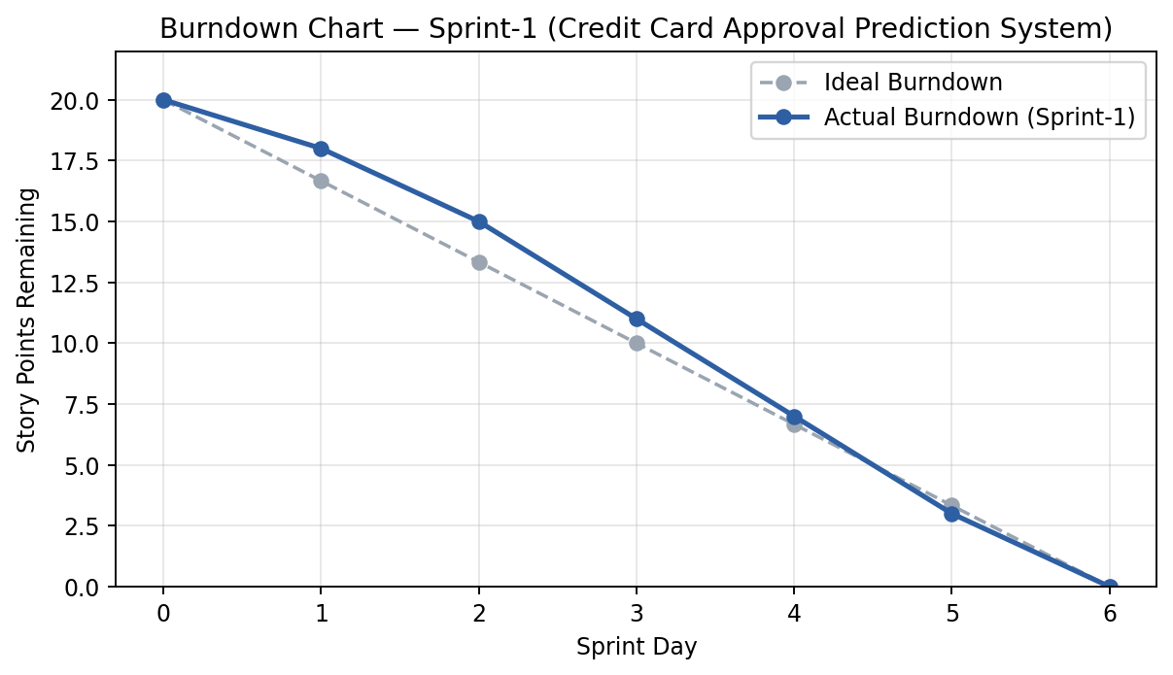

References
https://www.atlassian.com/agile/project-management
https://www.atlassian.com/agile/tutorials/how-to-do-scrum-with-jira-software
https://www.atlassian.com/agile/tutorials/epics
https://www.atlassian.com/agile/tutorials/sprints
https://www.atlassian.com/agile/project-management/estimation
https://www.atlassian.com/agile/tutorials/burndown-charts

